Lab Programming

Name:K.SAISOMASEKHAR REDDY Course code: CSA4708
Register Number: 192324134 Subject: Deep Learning

Experiment 1
Question: Flatten a 3 × 3 grayscale image matrix and calculate the sum of its pixel intensities.
Aim: To convert a 3 × 3 image matrix into a one-dimensional vector and calculate the total pixel intensity.
Procedure:
- Import NumPy.
- Create the 3 × 3 matrix.
- Flatten the matrix into a 1-D vector.
- Calculate and display the sum.
Python Code:
import numpy as np
A = np.array([[10, 20, 30],
[40, 50, 60],
[70, 80, 90]])
vector = A.flatten()
total = np.sum(A)
print("Flattened vector:", vector)
print("Total pixel intensity:", total)
Output:
Result: Thus, the matrix was flattened and the total pixel intensity was calculated as 450.
Experiment 2
Question: Calculate the predicted output using X = [4, 6, 8], W = [0.5, 0.3, 0.2], and bias b = 2.
Aim: To calculate the model output using the dot product of input features and weights, plus bias.
Procedure:
- Import NumPy.
- Create the input and weight vectors.
- Calculate their dot product.
- Add the bias and print the result.
Python Code:
import numpy as np
X = np.array([4, 6, 8])
W = np.array([0.5, 0.3, 0.2])
b = 2
output = np.dot(X, W) + b
print("Predicted output:", output)
Output:
Result: The predicted output was calculated as 7.8.

Experiment 3
Question: Multiply input matrix X = [[30, 60], [35, 70]] by weight matrix W = [[0.2, 0.5], [0.4, 0.3]].
Aim: To multiply two matrices and display the predicted output for both locations.
Procedure:
- Import NumPy.
- Create input and weight matrices.
- Use matrix multiplication.
- Display the resulting matrix.
Python Code:
import numpy as np
X = np.array([[30, 60],
[35, 70]])
W = np.array([[0.2, 0.5],
[0.4, 0.3]])
output = X @ W
print("Predicted output matrix:")
print(output)
Output:
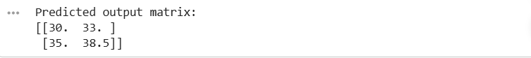
Result: The matrix multiplication produced the predicted output matrix shown above.

Experiment 4
Question: Update W = [0.7, 0.5, 0.9] using gradient G = [0.2, 0.1, 0.3] and learning rate 0.1.
Aim: To update model weights using the gradient descent rule.
Procedure:
- Import NumPy.
- Define the weights, gradient, and learning rate.
- Apply W_new = W - learning_rate × G.
- Print the updated weights.
Python Code:
import numpy as np
W = np.array([0.7, 0.5, 0.9])
G = np.array([0.2, 0.1, 0.3])
learning_rate = 0.1
updated_W = W - learning_rate * G
print("Updated weights:", updated_W)
Output:
Result: The weights were updated using gradient descent.

Experiment 5
Question: For A = [2, 4, 6] and B = [1, 3, 5], calculate vector addition and dot product.
Aim: To add two feature vectors and calculate their dot product.
Procedure:
- Import NumPy.
- Create vectors A and B.
- Add the vectors element by element.
- Calculate and display the dot product.
Python Code:
import numpy as np
A = np.array([2, 4, 6])
B = np.array([1, 3, 5])
print("Vector addition:", A + B)
print("Dot product:", np.dot(A, B))
Output:
Result: Vector addition and dot product were calculated successfully.

Experiment 6
Question: Calculate sample covariance for study hours [2, 4, 6, 8, 10] and marks [35, 45, 60, 75, 85], and draw a scatter plot.
Aim: To calculate sample covariance and visualize the relationship between study hours and marks.
Procedure:
- Import NumPy and Matplotlib.
- Create the two datasets.
- Calculate sample covariance using ddof=1.
- Draw and label a scatter plot.
Python Code:
import numpy as np
import matplotlib.pyplot as plt
hours = np.array([2, 4, 6, 8, 10])
marks = np.array([35, 45, 60, 75, 85])
cov = np.cov(hours, marks, ddof=1)[0, 1]
print("Sample covariance:", round(cov, 2))
plt.scatter(hours, marks)
plt.xlabel("Study Hours")
plt.ylabel("Examination Marks")
plt.title("Study Hours vs Marks")
plt.grid(True)
plt.show()
Output:
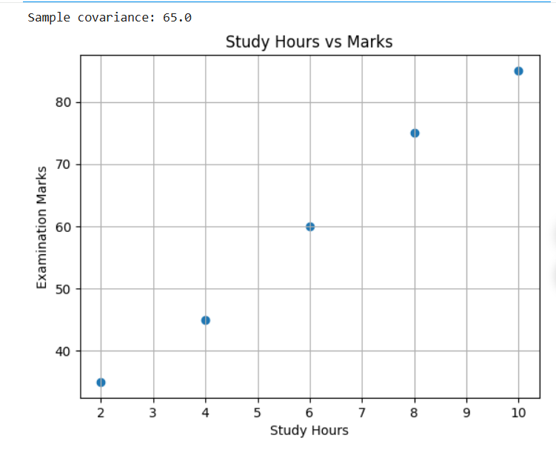

Result: The positive sample covariance indicates that marks tend to increase as study hours increase.

Experiment 7
Question: Calculate the covariance matrix for temperature [22, 25, 28, 30, 32] and humidity [80, 75, 68, 60, 55], and draw a scatter plot.
Aim: To calculate the covariance matrix of temperature and humidity and visualize their relationship.
Procedure:
- Import NumPy and Matplotlib.
- Create temperature and humidity arrays.
- Combine the arrays and calculate the sample covariance matrix.
- Plot temperature against humidity.
Python Code:
import numpy as np
import matplotlib.pyplot as plt
temperature = np.array([22, 25, 28, 30, 32])
humidity = np.array([80, 75, 68, 60, 55])
data = np.vstack((temperature, humidity))
print("Covariance matrix:")
print(np.cov(data, ddof=1))
plt.scatter(temperature, humidity)
plt.xlabel("Temperature")
plt.ylabel("Humidity")
plt.title("Temperature vs Humidity")
plt.grid(True)
plt.show()
Output:
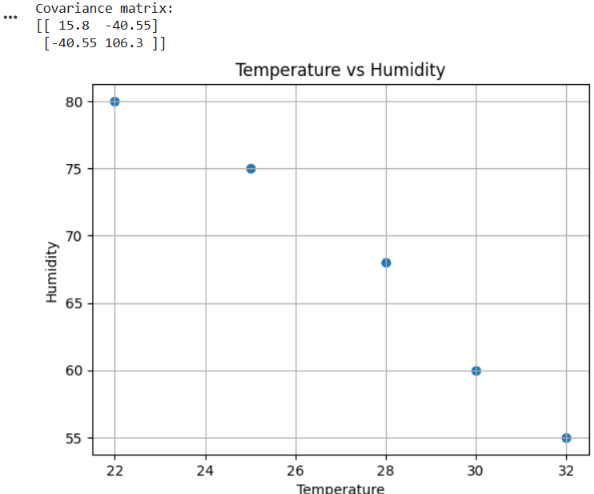
Result: The covariance matrix shows a negative relationship between temperature and humidity.
Experiment 8
Question: Calculate the eigenvalues of A = [[4, 2], [2, 4]] and display them in a bar chart.
Aim: To calculate and visualize the eigenvalues of a matrix.
Procedure:
- Import NumPy and Matplotlib.
- Create matrix A.
- Calculate its eigenvalues.
- Display the eigenvalues in a bar chart.
Python Code:
import numpy as np
import matplotlib.pyplot as plt
A = np.array([[4, 2],
[2, 4]])
values = np.linalg.eigvals(A)
print("Eigenvalues:", values)
plt.bar(["Eigenvalue 1", "Eigenvalue 2"], values)
plt.ylabel("Value")
plt.title("Eigenvalues of Matrix A")
plt.show()
Output:
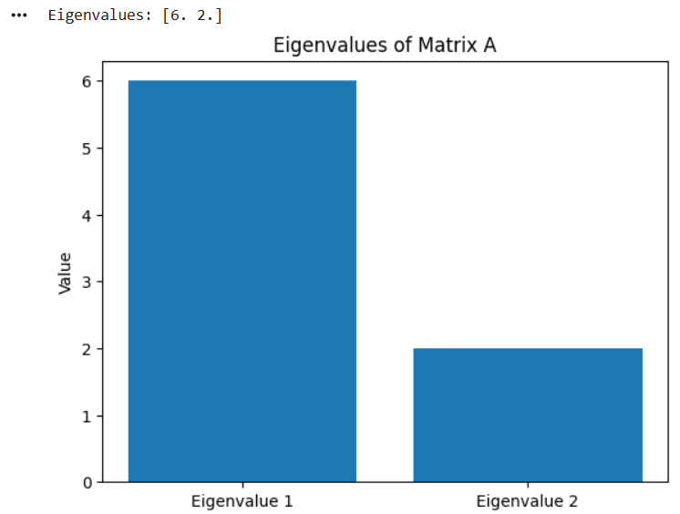
Result: The eigenvalues of the matrix are 6 and 2.

Experiment 9
Question: Calculate eigenvalues and eigenvectors of covariance matrix C = [[3, 1], [1, 3]] and plot the eigenvectors as arrows.
Aim: To calculate eigenvalues and eigenvectors and visualize the eigenvector directions.
Procedure:
- Import NumPy and Matplotlib.
- Create covariance matrix C.
- Calculate eigenvalues and eigenvectors.
- Draw each eigenvector as an arrow from the origin.
Python Code:
import numpy as np
import matplotlib.pyplot as plt
C = np.array([[3, 1],
[1, 3]])
values, vectors = np.linalg.eigh(C)
print("Eigenvalues:", values)
print("Eigenvectors (columns):")
print(vectors)
for i in range(2):
plt.quiver(0, 0, vectors[0, i], vectors[1, i],
angles="xy", scale_units="xy", scale=1,
label=f"Eigenvector {i+1}")
plt.xlim(-1.2, 1.2)
plt.ylim(-1.2, 1.2)
plt.axhline(0, color="black")
plt.axvline(0, color="black")
plt.grid(True)
plt.legend()
plt.title("Eigenvectors of C")
plt.show()
Output:
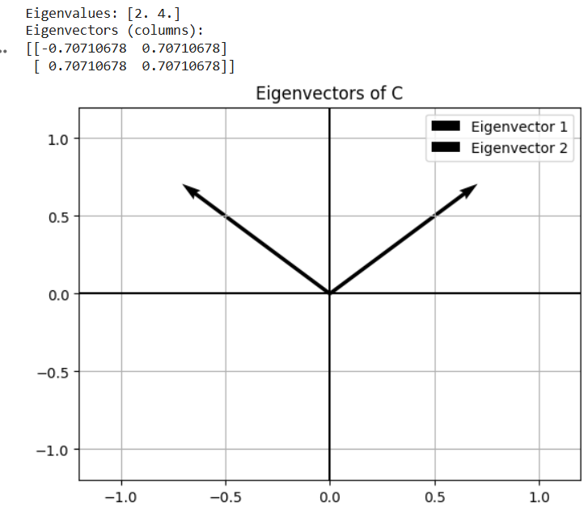
Result: The matrix has eigenvalues 2 and 4, with their corresponding eigenvector directions plotted.

Experiment 10
Question: For C = [[5, 2], [2, 2]], calculate eigenvalues/eigenvectors, identify the largest-eigenvalue eigenvector, and plot both vectors.
Aim: To identify the principal direction of variation using eigenvalue and eigenvector analysis.
Procedure:
- Import NumPy and Matplotlib.
- Create covariance matrix C.
- Calculate eigenvalues and eigenvectors.
- Find the eigenvector for the largest eigenvalue.
- Plot both eigenvectors.
Python Code:
import numpy as np
import matplotlib.pyplot as plt
C = np.array([[5, 2],
[2, 2]])
values, vectors = np.linalg.eigh(C)
idx = np.argsort(values)[::-1]
values = values[idx]
vectors = vectors[:, idx]
print("Eigenvalues:", values)
print("Eigenvectors (columns):")
print(vectors)
print("Principal eigenvector:", vectors[:, 0])
for i in range(2):
plt.quiver(0, 0, vectors[0, i], vectors[1, i],
angles="xy", scale_units="xy", scale=1,
label=f"Eigenvector {i+1}")
plt.xlim(-1.2, 1.2)
plt.ylim(-1.2, 1.2)
plt.axhline(0, color="black")
plt.axvline(0, color="black")
plt.grid(True)
plt.legend()
plt.title("Eigenvectors of Sensor Covariance Matrix")
plt.show()
Output:
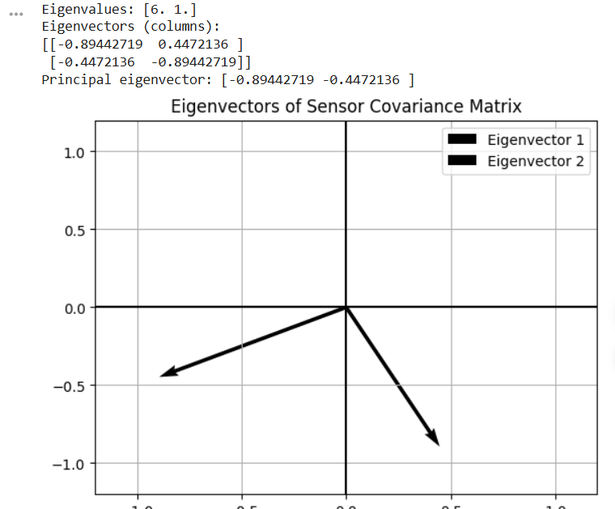

Result: The eigenvector corresponding to the largest eigenvalue represents the principal direction of variation.
Experiment 11
Question: For a binomial distribution with n = 20 and p = 0.1, calculate P(X = 3) and plot the PMF for 0–20 defects.
Aim: To calculate the probability of exactly three defective components and plot the binomial PMF.
Procedure:
- Import NumPy, Matplotlib, and the binomial distribution function.
- Set n = 20 and p = 0.1.
- Calculate P(X = 3).
- Plot probabilities for k = 0 to 20.
Python Code:
import numpy as np
import matplotlib.pyplot as plt
from math import comb
n, p = 20, 0.1
k = np.arange(0, n + 1)
pmf = np.array([comb(n, int(i)) * p**i * (1-p)**(n-i) for i in k])
prob = comb(n, 3) * p**3 * (1-p)**17
print("P(X = 3):", round(prob, 4))
plt.bar(k, pmf)
plt.xlabel("Number of defective components")
plt.ylabel("Probability")
plt.title("Binomial Distribution (n=20, p=0.1)")
plt.show()
Output:
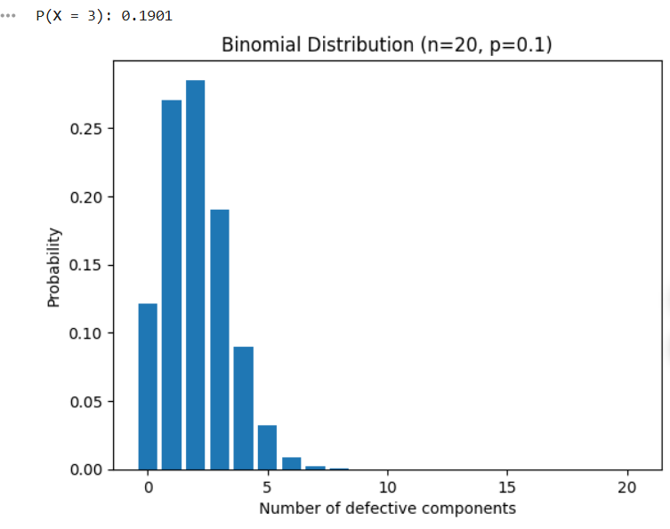
Result: The probability that exactly three components are defective is approximately 0.1901
Experiment 12
Question: For marks following a normal distribution with mean 70 and standard deviation 10, calculate P(60 ≤ X ≤ 80) and highlight the interval.
Aim: To calculate the probability of a score between 60 and 80 and visualize the normal distribution.
Procedure:
- Import NumPy, Matplotlib, and the normal distribution function.
- Set mean = 70 and standard deviation = 10.
- Calculate the CDF difference between 80 and 60.
- Plot the curve and shade the interval.
Python Code:
import numpy as np
import matplotlib.pyplot as plt
from math import erf, sqrt, pi
mu, sigma = 70, 10
cdf = lambda x: 0.5 * (1 + erf((x-mu)/(sigma*sqrt(2))))
prob = cdf(80) - cdf(60)
x = np.linspace(40, 100, 400)
y = (1/(sigma*sqrt(2*pi))) * np.exp(-0.5*((x-mu)/sigma)**2)
print("P(60 <= X <= 80):", round(prob, 4))
plt.plot(x, y)
mask = (x >= 60) & (x <= 80)
plt.fill_between(x[mask], y[mask], alpha=0.4)
plt.xlabel("Examination Marks")
plt.ylabel("Density")
plt.title("Normal Distribution (mean=70, SD=10)")
plt.show()
Output:
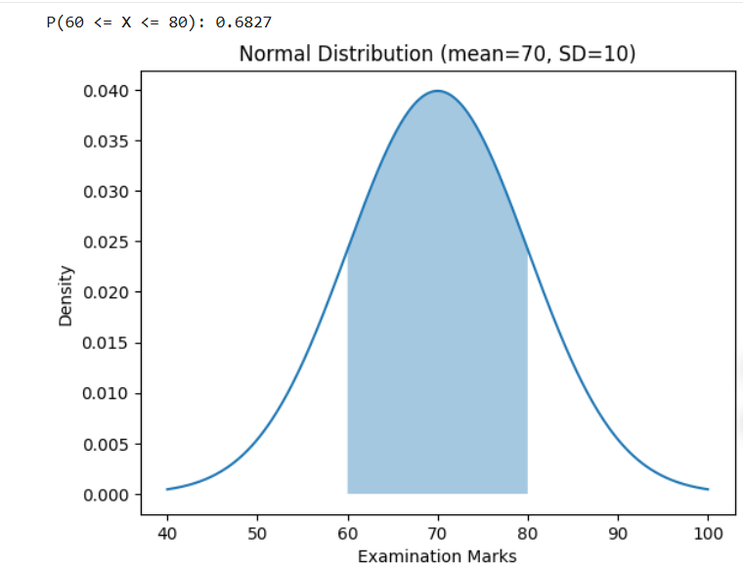
Result: The probability of scoring between 60 and 80 is approximately 68.27%
Experiment13
Question: For a Poisson distribution with average λ = 4 customers per 10 minutes, calculate P(X = 6) and plot k = 0–12.
Aim: To calculate the probability of exactly six customer arrivals and plot the Poisson PMF.
Procedure:
- Import NumPy and Matplotlib.
- Set λ = 4.
- Calculate Poisson probabilities for k = 0 to 12.
- Display P(X = 6) and plot the PMF.
Python Code:
import numpy as np
import matplotlib.pyplot as plt
from math import factorial, exp
lam = 4
k = np.arange(0, 13)
pmf = np.array([exp(-lam) * lam**int(i) / factorial(int(i)) for i in k])
prob = exp(-lam) * lam**6 / factorial(6)
print("P(X = 6):", round(prob, 4))
plt.bar(k, pmf)
plt.xlabel("Number of customers")
plt.ylabel("Probability")
plt.title("Poisson Distribution (lambda=4)")
plt.show()
Output:
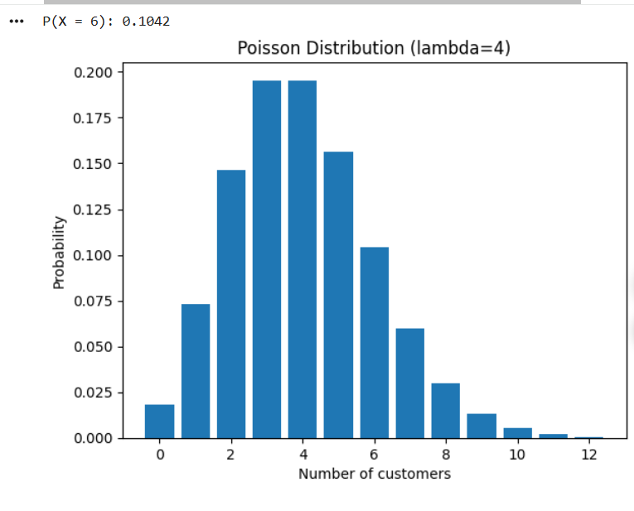
.Result: The probability of exactly six arrivals is approximately 0.1042.
Experiment 14
Question: Disease prevalence is 2%, sensitivity is 95%, and false-positive rate is 5%. Use Bayes’ theorem to calculate P(disease | positive) and compare prior/posterior probabilities.
Aim: To apply Bayes’ theorem and compare the prior and posterior probability of disease.
Procedure:
- Define prevalence, sensitivity, and false-positive rate.
- Apply Bayes’ theorem: posterior = sensitivity × prevalence / total positive probability.
- Print the posterior probability.
- Plot prior and posterior probabilities.
Python Code:
import matplotlib.pyplot as plt
prior = 0.02
sensitivity = 0.95
false_positive = 0.05
posterior = (sensitivity * prior) / (
sensitivity * prior + false_positive * (1 - prior)
)
print("Prior probability:", round(prior, 4))
print("P(Disease | Positive):", round(posterior, 4))
plt.bar(["Prior", "After positive test"], [prior, posterior])
plt.ylabel("Probability")
plt.title("Disease Probability Before and After Test")
plt.ylim(0, 1)
plt.show()
Output:
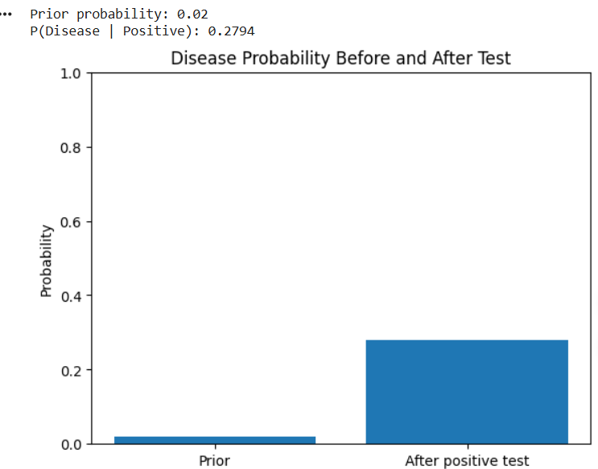
Prior probability: 0.02
P(Disease | Positive): 0.2794
A bar chart compares the prior probability (2%) and posterior probability (about 27.94%).
Result: After a positive test, the probability of disease is approximately 27.94%.

Experiment15
Question: Spam prevalence is 30%; “prize” appears in 70% of spam and 10% of non-spam emails. Calculate P(spam | prize) and plot prior/posterior probabilities.
Aim: To calculate the probability that an email is spam given that it contains the word “prize.”
Procedure:
- Define prior spam probability and word probabilities.
- Apply Bayes’ theorem.
- Print the posterior probability.
- Plot prior and posterior spam probabilities.
Python Code:
import matplotlib.pyplot as plt
prior_spam = 0.30
prize_given_spam = 0.70
prize_given_not_spam = 0.10
posterior = (prize_given_spam * prior_spam) / (
prize_given_spam * prior_spam +
prize_given_not_spam * (1 - prior_spam)
)
print("Prior probability of spam:", round(prior_spam, 4))
print("P(Spam | prize):", round(posterior, 4))
plt.bar(["Prior spam", "After word 'prize'"], [prior_spam, posterior])
plt.ylabel("Probability")
plt.title("Spam Probability Before and After Word Evidence")
plt.ylim(0, 1)
plt.show()
Output:
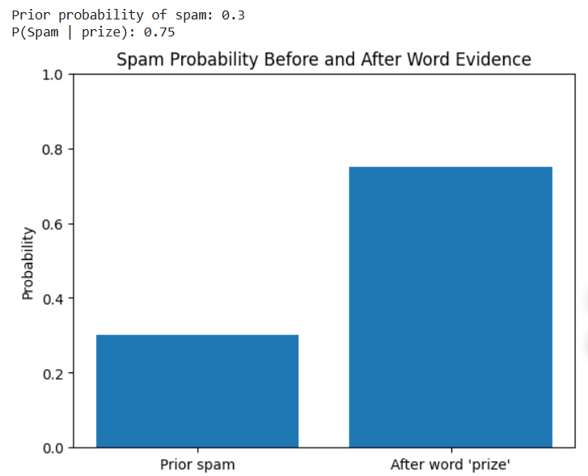
Prior probability of spam: 0.3
P(Spam | prize): 0.75
A bar chart compares the prior spam probability (30%) and posterior probability (75%).
Result: An email containing “prize” has a 75% probability of being spam under the given values.

Experiment 16
Question: For weather probabilities P = [0.6, 0.3, 0.1], calculate entropy and plot the probabilities.
Aim: To measure the uncertainty of the weather prediction distribution using entropy.
Procedure:
- Import NumPy and Matplotlib.
- Create the probability array.
- Calculate entropy using H = −Σ p log₂(p).
- Plot the probabilities.
Python Code:
import numpy as np
import matplotlib.pyplot as plt
P = np.array([0.6, 0.3, 0.1])
entropy = -np.sum(P * np.log2(P))
print("Entropy (bits):", round(entropy, 4))
plt.bar(["Sunny", "Rainy", "Cloudy"], P)
plt.ylabel("Probability")
plt.title("Weather Probabilities")
plt.show()
Output:
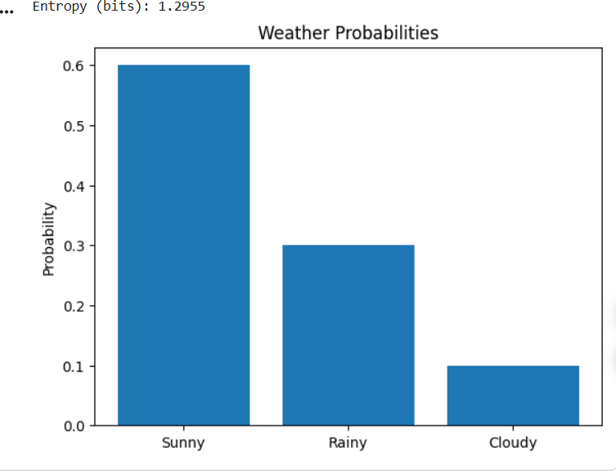
Result: The entropy of the weather distribution is approximately 1.2955 bits.

Experiment 17
Question: For actual class Y = [1, 0, 0] and predicted probabilities P = [0.7, 0.2, 0.1], calculate cross-entropy loss and compare probabilities.
Aim: To calculate cross-entropy loss and compare actual and predicted class probabilities.
Procedure:
- Import NumPy and Matplotlib.
- Create actual and predicted distributions.
- Calculate cross-entropy using −Σ y log(p).
- Plot the actual and predicted probabilities side by side.
Python Code:
import numpy as np
import matplotlib.pyplot as plt
Y = np.array([1, 0, 0])
P = np.array([0.7, 0.2, 0.1])
loss = -np.sum(Y * np.log(P))
print("Cross-entropy loss:", round(loss, 4))
x = np.arange(3)
plt.bar(x - 0.2, Y, width=0.4, label="Actual")
plt.bar(x + 0.2, P, width=0.4, label="Predicted")
plt.xticks(x, ["Cat", "Dog", "Bird"])
plt.ylabel("Probability")
plt.legend()
plt.title("Actual vs Predicted Probabilities")
plt.show()
Output:
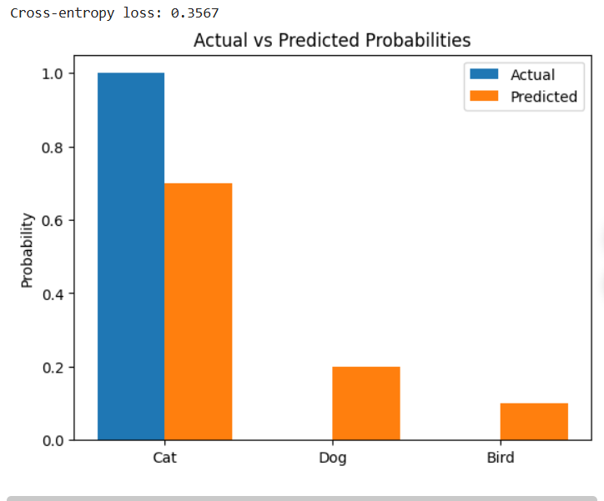

Result: The cross-entropy loss for the prediction is approximately 0.3567.

Experiment 18
Question: Calculate KL divergence for P = [0.5, 0.3, 0.2] and Q = [0.4, 0.4, 0.2], and compare them with a grouped bar chart.
Aim: To measure the difference between two probability distributions using KL divergence.
Procedure:
- Import NumPy and Matplotlib.
- Create distributions P and Q.
- Calculate D_KL(P || Q) = Σ P log(P/Q).
- Plot both distributions in a grouped bar chart.
Python Code:
import numpy as np
import matplotlib.pyplot as plt
P = np.array([0.5, 0.3, 0.2])
Q = np.array([0.4, 0.4, 0.2])
kl = np.sum(P * np.log(P / Q))
print("KL divergence (P || Q):", round(kl, 4))
x = np.arange(3)
plt.bar(x - 0.2, P, width=0.4, label="P")
plt.bar(x + 0.2, Q, width=0.4, label="Q")
plt.xticks(x, ["Class 1", "Class 2", "Class 3"])
plt.ylabel("Probability")
plt.legend()
plt.title("P and Q Distributions")
plt.show()
Output:
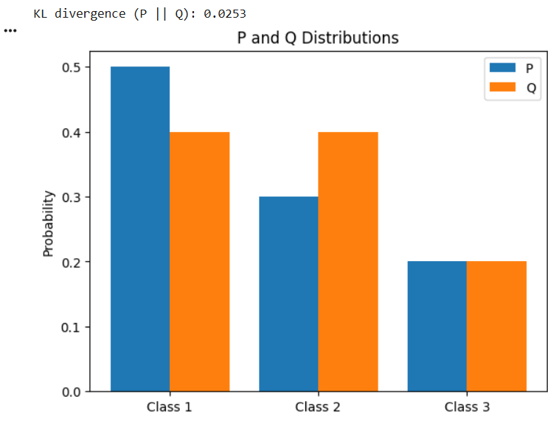
Result: The KL divergence from P to Q is approximately 0.0253 nats.
Experiment 19
Question: Calculate entropy for P = [0.9, 0.1] and Q = [0.5, 0.5], compare them in a bar chart, and identify the greater uncertainty.
Aim: To compare the uncertainty of two binary predictions using entropy.
Procedure:
- Import NumPy and Matplotlib.
- Create distributions P and Q.
- Calculate entropy for each distribution using natural logarithms.
- Plot both entropy values and identify the larger one.
Python Code:
import numpy as np
import matplotlib.pyplot as plt
P = np.array([0.9, 0.1])
Q = np.array([0.5, 0.5])
H_P = -np.sum(P * np.log(P))
H_Q = -np.sum(Q * np.log(Q))
print("Entropy of P:", round(H_P, 4))
print("Entropy of Q:", round(H_Q, 4))
plt.bar(["P = [0.9, 0.1]", "Q = [0.5, 0.5]"], [H_P, H_Q])
plt.ylabel("Entropy (nats)")
plt.title("Entropy Comparison")
plt.show()
print("Greater uncertainty: Q" if H_Q > H_P else "Greater uncertainty: P")
Output:
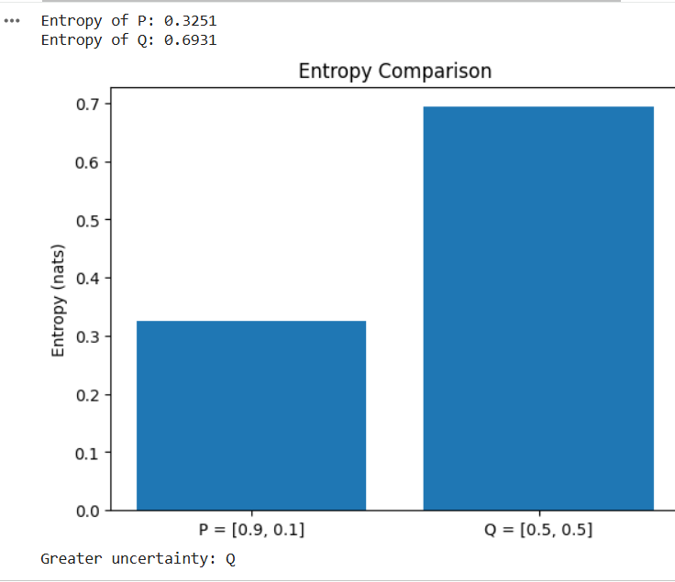

Result: Q has greater uncertainty because its two outcomes are equally probable.
Experiment 20
Question: For actual Y = [0, 1, 0, 0] and predicted P = [0.1, 0.6, 0.2, 0.1], calculate cross-entropy and KL divergence and visualize both distributions.
Aim: To calculate cross-entropy loss and KL divergence between the actual and predicted class distributions.
Procedure:
- Import NumPy and Matplotlib.
- Create actual distribution Y and predicted distribution P.
- Calculate cross-entropy and KL divergence with safe logarithms.
- Plot actual and predicted probabilities.
Python Code:
import numpy as np
import matplotlib.pyplot as plt
Y = np.array([0, 1, 0, 0], dtype=float)
P = np.array([0.1, 0.6, 0.2, 0.1], dtype=float)
cross_entropy = -np.sum(Y * np.log(P))
kl = np.sum(Y[Y > 0] * np.log(Y[Y > 0] / P[Y > 0]))
print("Cross-entropy loss:", round(cross_entropy, 4))
print("KL divergence D(Y || P):", round(kl, 4))
x = np.arange(4)
plt.bar(x - 0.2, Y, width=0.4, label="Actual")
plt.bar(x + 0.2, P, width=0.4, label="Predicted")
plt.xticks(x, ["Class 1", "Class 2", "Class 3", "Class 4"])
plt.ylabel("Probability")
plt.legend()
plt.title("Actual vs Predicted Distribution")
plt.show()
Output:
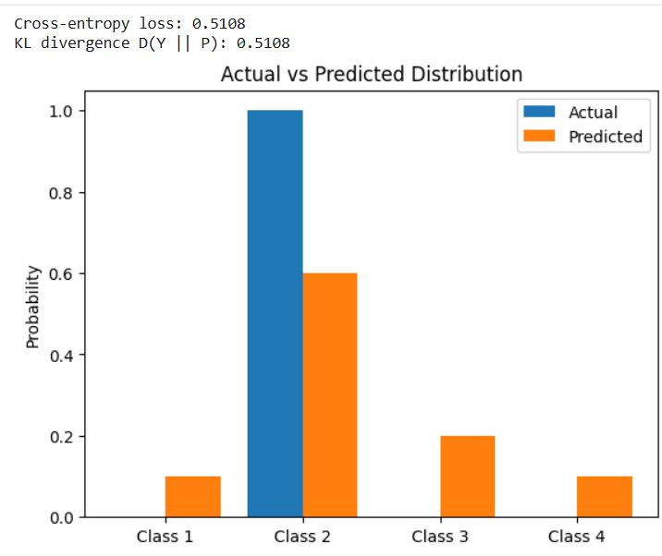
.
Result: The cross-entropy and KL divergence are both approximately 0.5108 nats because Y is a one-hot distribution.

Experiment 21
Question: Generate sample house-price data, train polynomial regression models of degrees 1, 2, and 10, and plot their curves against the data.
Aim: To compare model complexity using linear, quadratic, and degree-10 polynomial regression.
Procedure:
- Import NumPy, Matplotlib, and scikit-learn tools.
- Generate sample house-area and price data.
- Fit polynomial regression models of degrees 1, 2, and 10.
- Plot the observed data and each model curve.
Python Code:
import numpy as np
import matplotlib.pyplot as plt
from sklearn.pipeline import make_pipeline
from sklearn.preprocessing import PolynomialFeatures
from sklearn.linear_model import LinearRegression
np.random.seed(1)
X = np.linspace(500, 3000, 30).reshape(-1, 1)
y = 50000 + 120*X.ravel() + 0.015*(X.ravel()**2) + np.random.normal(0, 60000, 30)
x_plot = np.linspace(500, 3000, 300).reshape(-1, 1)
plt.scatter(X, y, label="Actual data")
for degree in [1, 2, 10]:
model = make_pipeline(PolynomialFeatures(degree), LinearRegression())
model.fit(X, y)
plt.plot(x_plot, model.predict(x_plot), label=f"Degree {degree}")
plt.xlabel("House Area")
plt.ylabel("House Price")
plt.title("Polynomial Regression Model Comparison")
plt.legend()
plt.show()
Output:
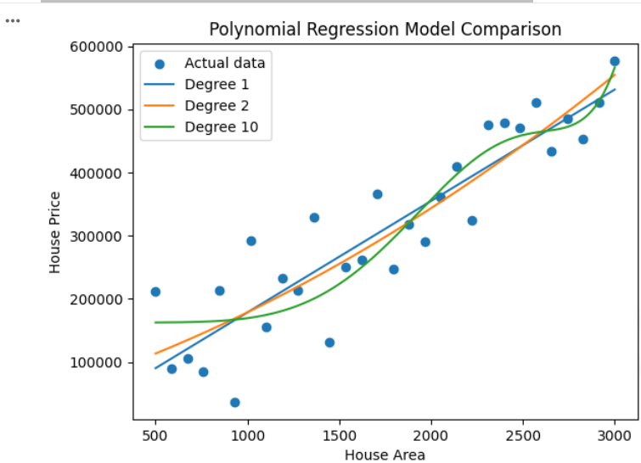
Result: The plot compares simple and complex models; a very high-degree curve may overfit the sample data.

Experiment 22
Question: Generate nonlinear student-performance data, train linear regression, calculate training and testing MSE, and compare actual and predicted marks.
Aim: To evaluate a linear regression model on nonlinear data using training and testing mean squared error.
Procedure:
- Generate nonlinear study-hour and marks data.
- Split data into training and testing sets.
- Train a linear regression model.
- Calculate training and testing MSE and plot predictions.
Python Code:
import numpy as np
import matplotlib.pyplot as plt
from sklearn.model_selection import train_test_split
from sklearn.linear_model import LinearRegression
from sklearn.metrics import mean_squared_error
np.random.seed(2)
X = np.linspace(0, 10, 100).reshape(-1, 1)
y = 5*X.ravel() + 2*(X.ravel()**2) + np.random.normal(0, 5, 100)
X_train, X_test, y_train, y_test = train_test_split(
X, y, test_size=0.2, random_state=42
)
model = LinearRegression()
model.fit(X_train, y_train)
train_pred = model.predict(X_train)
test_pred = model.predict(X_test)
print("Training MSE:", round(mean_squared_error(y_train, train_pred), 2))
print("Testing MSE:", round(mean_squared_error(y_test, test_pred), 2))
plt.scatter(X_test, y_test, label="Actual marks")
order = np.argsort(X_test[:, 0])
plt.plot(X_test[order], test_pred[order], label="Linear predictions")
plt.xlabel("Study Hours")
plt.ylabel("Marks")
plt.title("Actual vs Linear Predictions")
plt.legend()
plt.show()
Output:
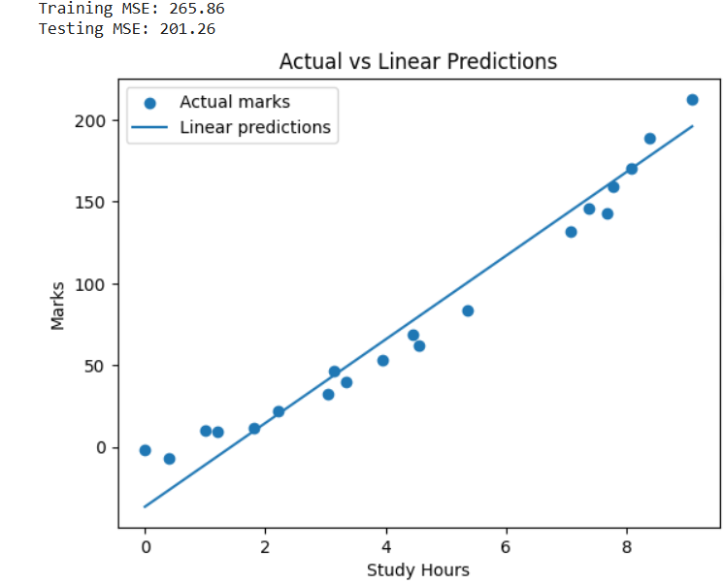
.
Result: The training and testing errors show how well a linear model fits the nonlinear student-performance data.

Experiment 23
Question: Generate nonlinear data, train polynomial regression models of degrees 2 and 15, calculate training/testing errors, and compare fitted curves.
Aim: To compare a moderate polynomial model with a high-degree model and observe possible overfitting.
Procedure:
- Generate noisy nonlinear data.
- Split data into training and testing sets.
- Fit polynomial models of degrees 2 and 15.
- Print both errors and plot the fitted curves.
Python Code:
import numpy as np
import matplotlib.pyplot as plt
from sklearn.model_selection import train_test_split
from sklearn.pipeline import make_pipeline
from sklearn.preprocessing import PolynomialFeatures
from sklearn.linear_model import LinearRegression
from sklearn.metrics import mean_squared_error
np.random.seed(3)
X = np.linspace(-3, 3, 60).reshape(-1, 1)
y = X.ravel()**2 + np.sin(2*X.ravel()) + np.random.normal(0, 1.2, 60)
X_train, X_test, y_train, y_test = train_test_split(
X, y, test_size=0.25, random_state=42
)
x_plot = np.linspace(-3, 3, 300).reshape(-1, 1)
plt.scatter(X_train, y_train, label="Training data")
for degree in [2, 15]:
model = make_pipeline(PolynomialFeatures(degree), LinearRegression())
model.fit(X_train, y_train)
print(f"Degree {degree} training MSE:",
round(mean_squared_error(y_train, model.predict(X_train)), 3))
print(f"Degree {degree} testing MSE:",
round(mean_squared_error(y_test, model.predict(X_test)), 3))
plt.plot(x_plot, model.predict(x_plot), label=f"Degree {degree}")
plt.xlabel("X")
plt.ylabel("Y")
plt.title("Polynomial Degree Comparison")
plt.legend()
plt.ylim(-5, 15)
plt.show()
Output:
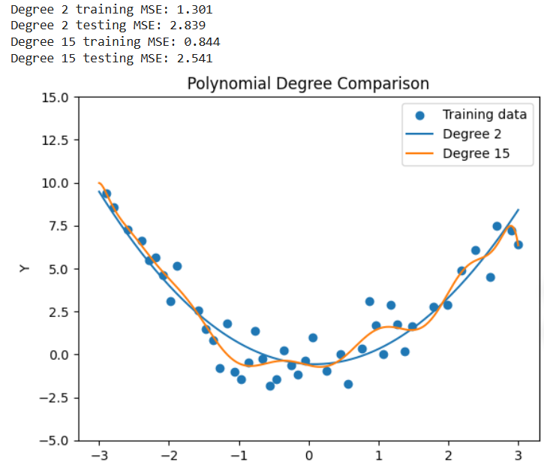
Result: The degree-15 model is more complex and may fit training noise, resulting in overfitting.

Experiment 24
Question: Generate sample temperature data, train polynomial models of degrees 1, 3, and 12, calculate training/testing MSE, and compare performance.
Aim: To compare temperature prediction models with different polynomial degrees using mean squared error.
Procedure:
- Generate sample time and temperature data.
- Split the data into training and testing sets.
- Train polynomial models of degrees 1, 3, and 12.
- Print training/testing MSE and plot the fitted curves.
Python Code:
import numpy as np
import matplotlib.pyplot as plt
from sklearn.model_selection import train_test_split
from sklearn.pipeline import make_pipeline
from sklearn.preprocessing import PolynomialFeatures
from sklearn.linear_model import LinearRegression
from sklearn.metrics import mean_squared_error
np.random.seed(4)
X = np.linspace(0, 24, 80).reshape(-1, 1)
y = 20 + 5*np.sin(2*np.pi*X.ravel()/24) + np.random.normal(0, 1.2, 80)
X_train, X_test, y_train, y_test = train_test_split(
X, y, test_size=0.25, random_state=42
)
x_plot = np.linspace(0, 24, 300).reshape(-1, 1)
plt.scatter(X_train, y_train, label="Training data")
for degree in [1, 3, 12]:
model = make_pipeline(PolynomialFeatures(degree), LinearRegression())
model.fit(X_train, y_train)
train_mse = mean_squared_error(y_train, model.predict(X_train))
test_mse = mean_squared_error(y_test, model.predict(X_test))
print(f"Degree {degree}: training MSE={train_mse:.3f}, testing MSE={test_mse:.3f}")
plt.plot(x_plot, model.predict(x_plot), label=f"Degree {degree}")
plt.xlabel("Time (hours)")
plt.ylabel("Temperature")
plt.title("Temperature Model Comparison")
plt.legend()
plt.show()
Output:
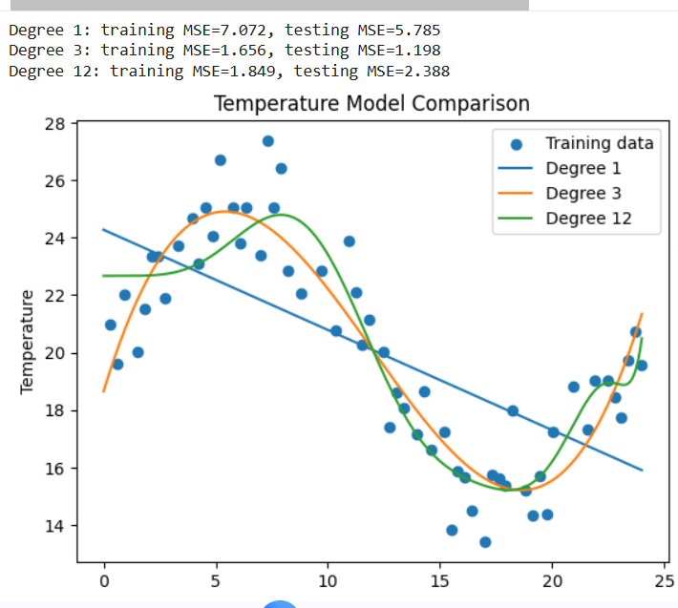
.
Result: Comparing the training and testing MSE helps identify a model that balances simplicity and accuracy.

Experiment 25
Question: Generate a regression dataset, calculate learning curves for linear regression and high-degree polynomial regression, and plot training/validation errors against training size.
Aim: To study bias and variance by comparing learning curves for a linear model and a high-degree polynomial model.
Procedure:
- Generate a noisy regression dataset and split it into training and validation sets.
- Create linear and degree-12 polynomial models.
- Train each model on increasing training-set sizes.
- Calculate training and validation MSE for each size.
- Plot both learning curves.
Python Code:
import numpy as np
import matplotlib.pyplot as plt
from sklearn.model_selection import train_test_split
from sklearn.pipeline import make_pipeline
from sklearn.preprocessing import PolynomialFeatures
from sklearn.linear_model import LinearRegression
from sklearn.metrics import mean_squared_error
np.random.seed(5)
X = np.linspace(-3, 3, 120).reshape(-1, 1)
y = X.ravel()**2 + np.sin(2*X.ravel()) + np.random.normal(0, 1, 120)
X_train, X_val, y_train, y_val = train_test_split(
X, y, test_size=0.25, random_state=42
)
models = {
"Linear": LinearRegression(),
"Degree 12": make_pipeline(PolynomialFeatures(12), LinearRegression())
}
sizes = np.linspace(10, len(X_train), 10, dtype=int)
for name, model in models.items():
train_errors, val_errors = [], []
for size in sizes:
model.fit(X_train[:size], y_train[:size])
train_errors.append(mean_squared_error(y_train[:size], model.predict(X_train[:size])))
val_errors.append(mean_squared_error(y_val, model.predict(X_val)))
plt.plot(sizes, train_errors, marker="o", label=f"{name} training")
plt.plot(sizes, val_errors, marker="s", linestyle="--", label=f"{name} validation")
plt.xlabel("Number of Training Samples")
plt.ylabel("Mean Squared Error")
plt.title("Learning Curves")
plt.legend()
plt.grid(True)
plt.show()
Output:
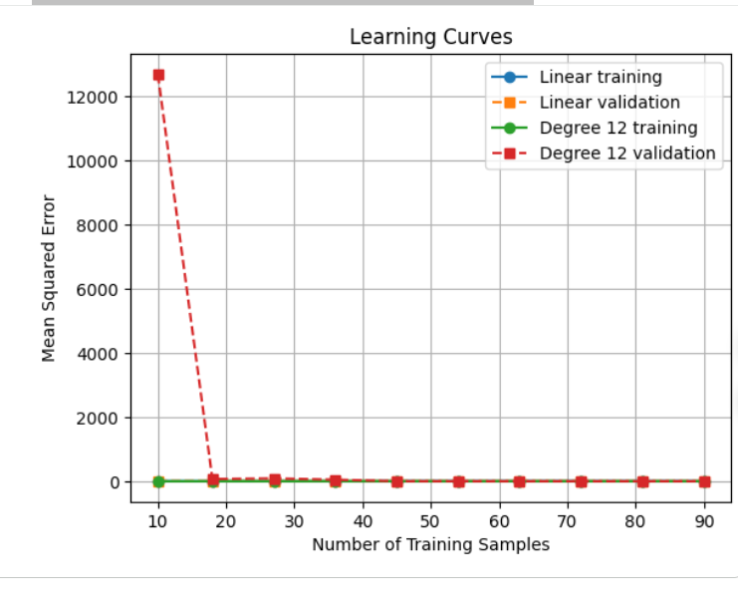

Result: The learning curves help indicate whether each model is underfitting or overfitting.

